

User mANUAL

# Subin Jeong, Joowon Lim, Hakyeong Kim, Tim Burkhart, mitchell etzel

Product Name: Haru (하루)

Team Name: One Day

Revision Number: 1

Revision Date: 07/25/2016

# First steps

* Have Android Studio installed with all the Google SDKs
* Go to: <https://github.com/Grazioso-Haru/Haru>
* Download master branch
* Open Android Studio and press Open Project
* Navigate to where you have downloaded the master branch
* Select the Haru Prototype and press Open
* Attach suitable Android phone
* Build/Run Haru Prototype on phone

# hARU NAVIGATION

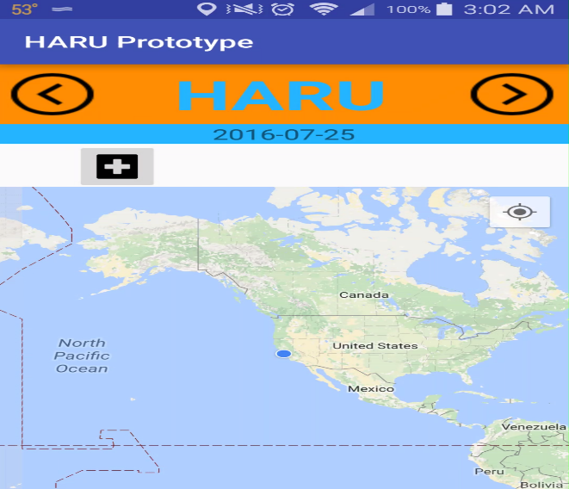

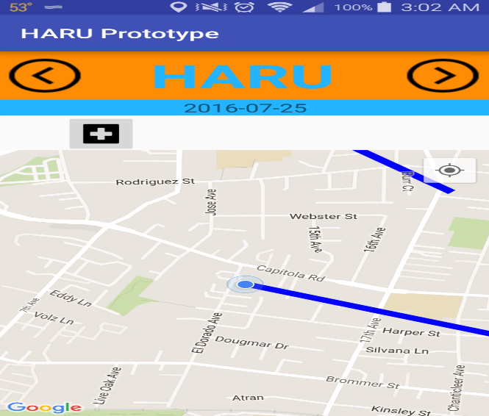

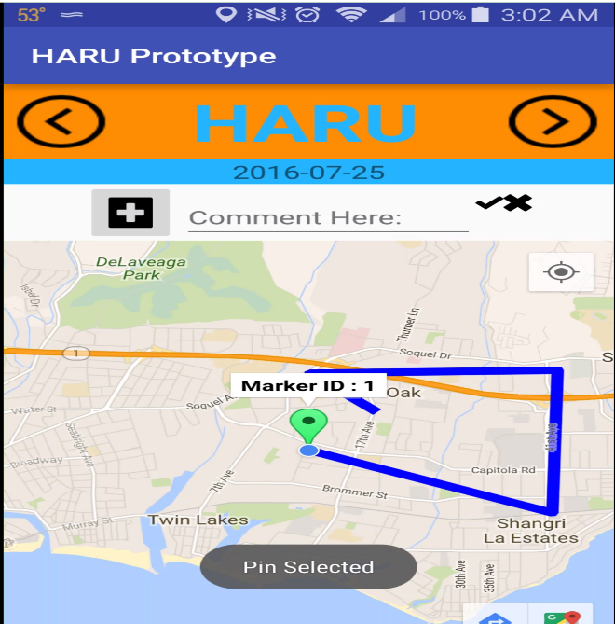

* Upon opening Haru press the Compass Icon in the upper right hand corner of the map to zoom in to your location
* To add a Personal Pin, press the black addition sign above the map and then tap on it
* If you tap and hold the pin you can move it anywhere on the map you want it to be

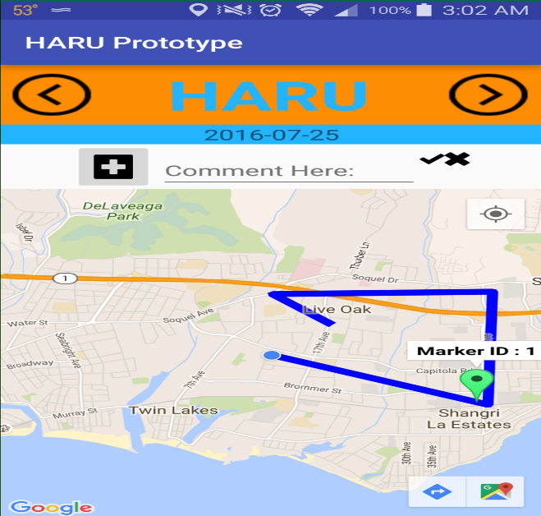

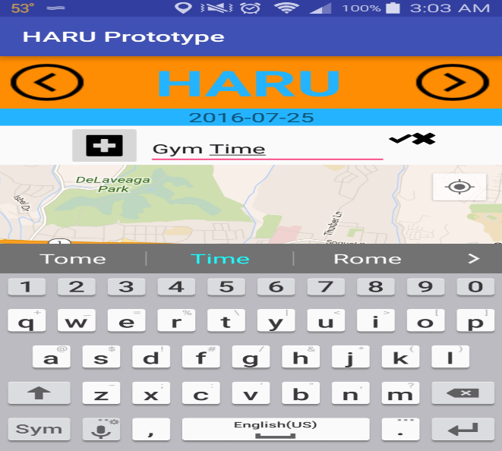

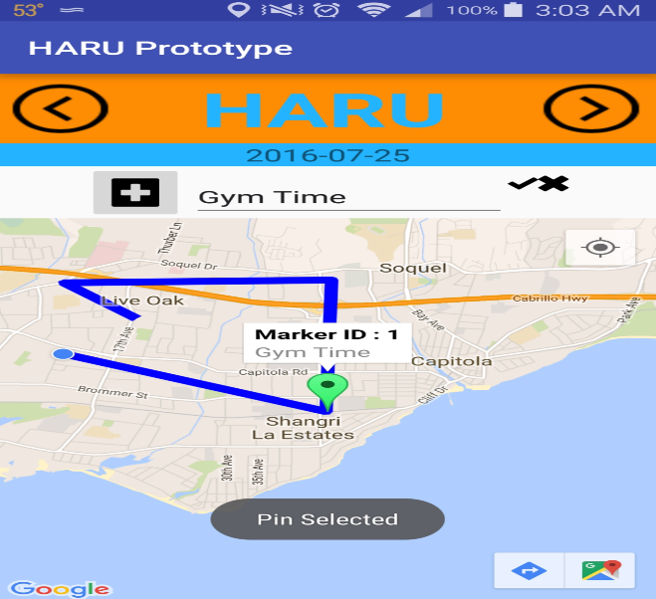

* Tap on the Comment Textbox to input your personal statement onto the pin
* Once done press the black check button and press back on your phone to get out of editing mode
* Tap the pin again to see the new message and then tap the blue Haru emblem to sync the new pin

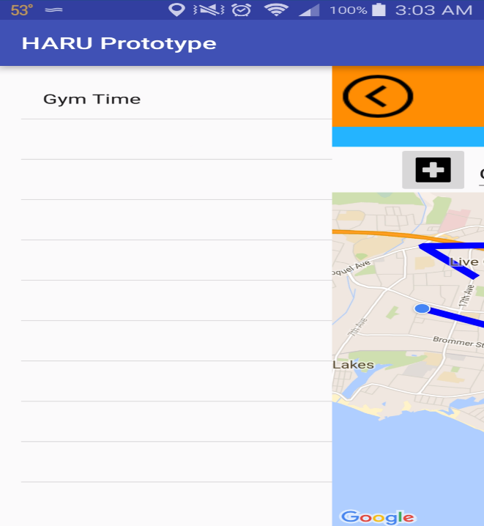

* You can now see the new comment on your Diary page.